1. create-react-app city-tours
2. npm start
3. clare index.css + app.css
4. add font and icon to index.html in public folder
5. <!-- google fonts -->
6. <link
7. href="https://fonts.googleapis.com/css?family=Open+Sans"
8. rel="stylesheet"
9. />
10. <!-- font awesome -->
11. <link
12. rel="stylesheet"
13. href="https://use.fontawesome.com/releases/v5.5.0/css/all.css"
14. integrity="sha384-B4dIYHKNBt8Bc12p+WXckhzcICo0wtJAoU8YZTY5qE0Id1GSseTk6S+L3BlXeVIU"
15. crossorigin="anonymous"
16. />
17. <title>City Tours</title>
18. npm i node-sass –save
19. rename index.css to index.scss and app.css to scss
20. and change in index.js and app.js
21. in index.scss add this
22. \* { margin: 0;
23. padding: 0;
24. box-sizing: border-box;
25. }
26. $mainBlack: #222;
27. $mainGreen: #82b340;
28. $mainWhite: #fff;
29. $mainGrey: #ececec;
30. body {
31. background: $mainGreen;
32. color: $mainBlack;
33. font-family: "Open Sans", sans-serif;
34. }
35. 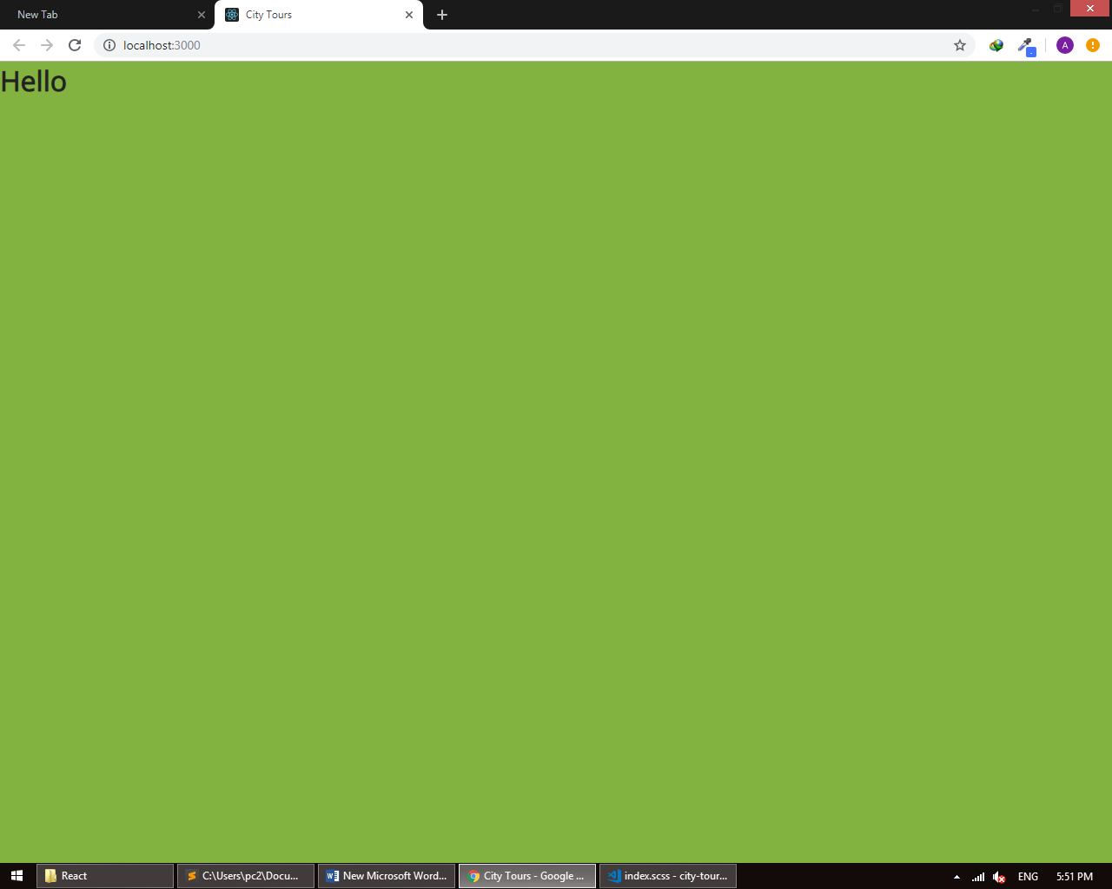
36. Create components in scr
37. Create Navbar + Tour + TourList folders
38. In navbar folder create Navbar.js + Navbar.scss
39. In Navbar.js add
40. import React from "react";
41. import "./Navbar.scss";
42. import logo from "../../logo.png";
43. export default function Navbar() {
44. return (
45. <nav className="navbar">
46. <img src={logo} alt="city tours logo" />
47. <ul className="nav-links">
48. <li>
49. <a href="/" className="nav-link">
50. home
51. </a>
52. </li>
53. <li>
54. <a href="/" className="nav-link">
55. about
56. </a>
57. </li>
58. <li>
59. <a href="/" className="nav-link active">
60. tours
61. </a>
62. </li>
63. </ul>
64. </nav>
65. );
66. }
67. In Navbar.scss
68. @import "../../index.scss";
69. .navbar {
70. background: $mainBlack;
71. padding: 0.5rem 1rem;
72. display: grid;
73. grid-template-columns: auto 1fr;
74. }
75. .nav-links {
76. align-self: center;
77. list-style-type: none;
78. display: grid;
79. grid-template-columns: repeat(3, 1fr);
80. text-align: center;
81. }
82. .nav-link {
83. color: $mainGrey;
84. text-transform: capitalize;
85. text-decoration: none;
86. font-size: 1.2rem;
87. transition: all 0.3s linear;
88. &:hover {
89. color: $mainGreen;
90. }
91. }
92. .active {
93. color: $mainGreen;
94. }
95. In app.js
96. import React, { Component } from 'react';
97. import Navbar from "./components/Navbar/Navbar";
98. import './App.scss';
99. class App extends Component {
100. render() {
101. return (
102. < main >
103. <Navbar / >
104. </main>
105. );
106. }
107. }
108. export default App;
109. 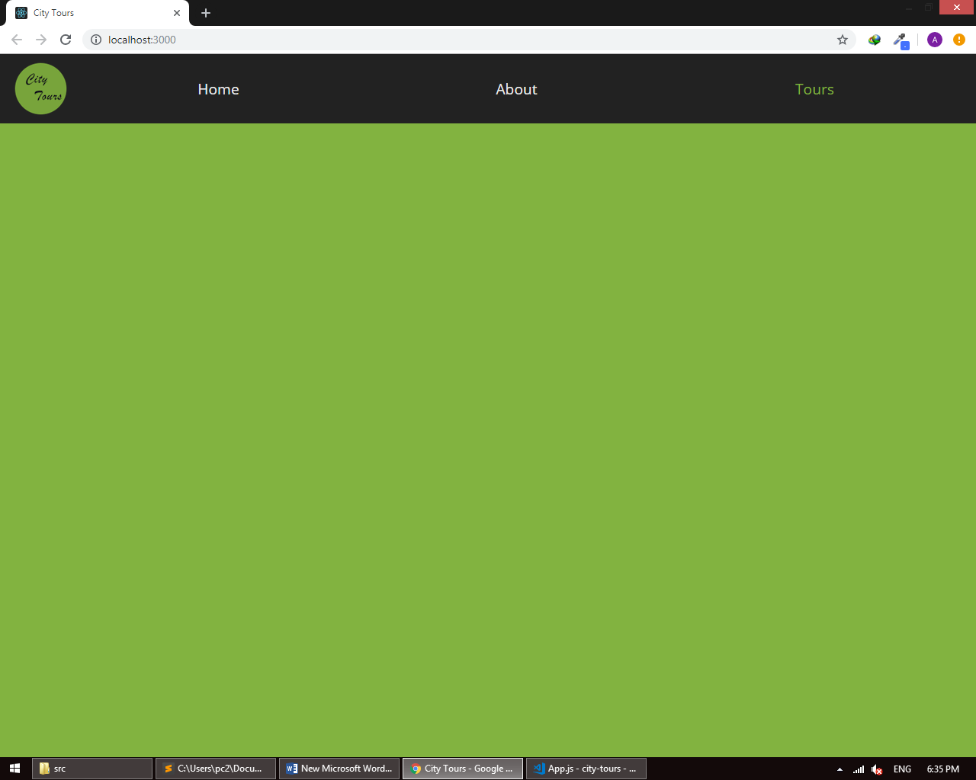
110. Create file tourData.js in coponents
111. export const tourData = [{
112. id: 1,
113. city: "new york",
114. img: "./img/newyork.jpeg",
115. name: "new york bridge tour",
116. info: "Lorem ipsum dolor sit amet consectetur adipisicing elit. Vel,repellendus!"
117. },
118. {
119. id: 2,
120. city: "paris",
121. img: "./img/paris.jpeg",
122. name: "paris lights tour",
123. info: "Lorem ipsum dolor sit amet consectetur adipisicing elit. Vel,repellendus!"
124. },
125. {
126. id: 3,
127. city: "london",
128. img: "./img/london.jpeg",
129. name: "london royal palace tour",
130. info: "Lorem ipsum dolor sit amet consectetur adipisicing elit. Vel,repellendus!"
131. },
132. {
133. id: 4,
134. city: "tokyo",
135. img: "./img/tokyo.jpeg",
136. name: "tokyo sushi tour",
137. info: "Lorem ipsum dolor sit amet consectetur adipisicing elit. Vel,repellendus!"
138. }
139. ];
140. In tour create file Tour.js
141. import React, { Component } from "react";
142. import "./Tour.scss";
143. export default class Tour extends Component {
144. state = {
145. showInfo: false
146. };
147. handleInfo = () => {
148. this.setState({
149. showInfo: !this.state.showInfo
150. });
151. };
152. render() {
153. const { id, city, img, name, info } = this.props.tour;
154. const { removeTour } = this.props;
155. return (
156. <article className="tour">
157. <div className="img-container">
158. <img src={img} alt="" />
159. <span
160. className="close-btn"
161. onClick={() => {
162. removeTour(id);
163. }}
164. >
165. <i className="fas fa-window-close" />
166. </span>
167. </div>
168. <div className="tour-info">
169. <h3>{city}</h3>
170. <h4>{name}</h4>
171. <h5>
172. info{" "}
173. <span onClick={this.handleInfo}>
174. <i className="fas fa-caret-square-down" />
175. </span>
176. </h5>
177. {this.state.showInfo && <p>{info}</p>}
178. </div>
179. </article>
180. );
181. }
182. }
183. In TourList create file index.js
184. import React, { Component } from "react";
185. import "./TourList.scss";
186. import Tour from "../Tour/Tour";
187. import { tourData } from "../tourData";
188. export default class TourList extends Component {
189. state = {
190. tours: tourData
191. };
192. removeTour = id => {
193. console.log(id);
194. const { tours } = this.state;
195. const sortedTours = tours.filter(tour => tour.id !== id);
196. this.setState({
197. tours: sortedTours
198. });
199. };
200. render() {
201. const { tours } = this.state;
202. return (
203. <section className="tourlist">
204. {tours.map(tour => (
205. <Tour key={tour.id} tour={tour} removeTour={this.removeTour} />
206. ))}
207. </section>
208. );
209. }
210. }
211. In app.js
212. import React, { Component } from 'react';
213. import Navbar from "./components/Navbar/Navbar";
214. import './App.scss';
215. import TourList from "./components/TourList";
216. class App extends Component {
217. render() {
218. return (
219. < main >
220. <Navbar />
221. < TourList / >
222. </main>
223. );
224. }
225. }
226. export default App;